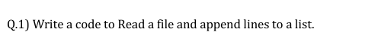
# File content ->
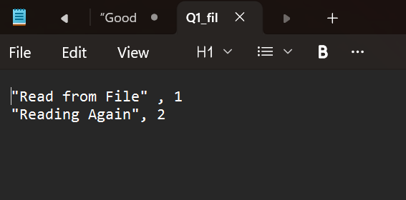
# Code
path = "D:\\downloads\\Q1_file.txt"
lines_list = []
with open(path, 'r') as file:
for line in file:
lines_list.append(line.strip())
print(lines_list)

#Output ->
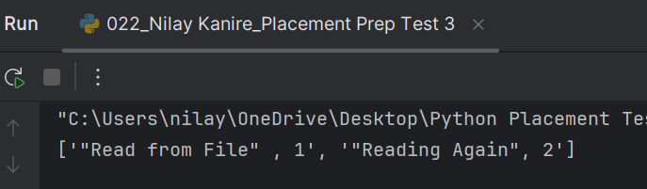

num = 10
deno = 0
try:
div = 10/0
except Exception as e:
print("Exception handled: ", e)
print("Done")

# Output ->
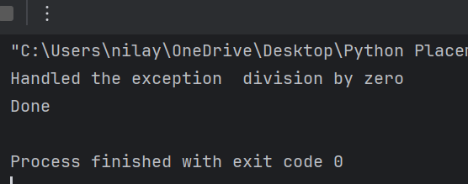

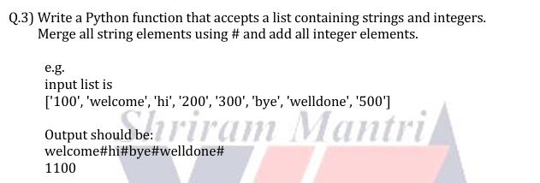

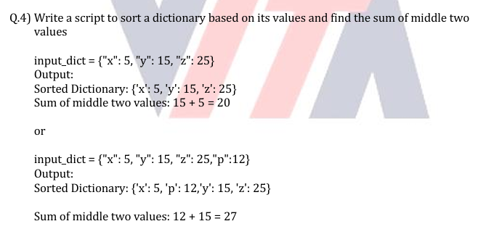
input_dict1 = {"x": 5, "y": 15, "z": 25}
sorted_dict1 = dict(sorted(input_dict1.items(), key=lambda item: item[1]))
input_dict2 = {"x": 5, "y": 15, "z": 25, "p": 12}
sorted_dict2 = dict(sorted(input_dict2.items(), key=lambda item: item[1]))
print("Sorted Dictionary 1 :", sorted_dict1)
values1 = list(sorted_dict1.values())
middle_values = values1[len(values1)//2 - 1 : len(values1)//2 + 1]
print("Sum of middle two values of Dictionary 1:", sum(middle_values))
print("\n Sorted Dictionary 2 :", sorted_dict2)
values2 = list(sorted_dict2.values())
middle_values = values2[len(values2)//2 - 1 : len(values2)//2 + 1]
print("Sum of middle two values of Dictionary 1:", sum(middle_values))
# Output ->
